## **WATER LEVEL INDICATOR**

## **PROJECT REPORT**



**MAQSOOD AHMED 38186**

**MUHAMMAD ARSALAN ZAFAR 38033**

**Department of Computer Science IQRA UNIVERSITY, ISLAMABAD**

## Objective:

* Indicate the water level through LEDs
* Give an alarm when the tank is full

## Components:

Following are the components that are used to make this project:

1. LEDs
2. Battery
3. Breadboard
4. Jumper wires
5. Buzzer
6. Transistor
7. Switch
8. Ruler
9. Container

In this water level measuring circuit, the transistor acts as a switch. When the water level reaches the wire connected to the base of the transistor, a small current flows into the base. This current is enough to turn on the transistor. When the transistor is turned on, it allows a larger current to flow from the collector to the emitter.

We are using an NPN type transistor, NPN transistors work best with a positive voltage on their collector and emitter, which aligns well with the water configuration. In contrast, PNP transistors require a negative voltage on their collector, making them a less natural fit for typical water level circuits.

BC 547 is cost effective and easily available transistor, that we are using in this project. The BC 547 has a moderate current gain. This means a small change in base current can control a much larger current flow between collector and emitter, making it efficient for driving indicator LEDs. It very helpful because water is weak electrolyte, current flow face a lot of difficulty and only a small of current of follow through water. Here is base pin can work on small current and turn ON the transistor.

We used normal white LEDs with 9V battery and male to female and make to male jumper wires, with a small DC buzzer.

## Procedure:

Transistor act as a switch in this circuit and its collector is connected to positive terminal of battery, base which is control pin is connected to a wire which can be used to measure the water level and emitter is connected to LED which glow when the base pin is positive.

We used 4 transistor on the breadboard and short their collector pin and connect it to positive terminal of battery. With emitter of each transistor we connected a LED to indicate that level For the wire which will go in container which will show water level at different percentage are connected to the base pin of transistor.

The negative terminal of the LEDs is connected to single column where the negative terminal of all LEDs are connected and it then connected to the negative terminal of battery.

We add a switch to whenever we want to on the circuit we can do with the switch, no need of removing the wires. Positive terminal of battery is connected to the one of the terminal of switch and other terminal wire is connected to breadboard.

There is a buzzer that goes off when the water is at 100%, we connected that buzzer positive wire to emitter. So, when that transistor is on the LED and buzzer turn on. The negative terminal of buzzer is connected to the negative terminal of battery.

To measure the water level at different level, we are using a ruler and connected different level wire at certain height so that when water reaches to them, the flow of current begins. The positive wire form the battery is connected at the bottom the ruler which introduce the current in water and then different level wire catches that current when they are submerged in water.

The benefit of the scale it is easy to put in the container and remove form it. It also make testing of the circuit a lot easier. Another benefit of the using a ruler is that you can use it for your desire water measuring system and install any four level of your choice.

## Features:

* It can measure water in container at 25%, 50%, 75% and 100%.
* LED will indicate each respective level.
* An alarm that will turn on when water reaches 100%.
* Switch prevent the wastage of power.

## Hardware:

Here is the label diagram of our hardware;

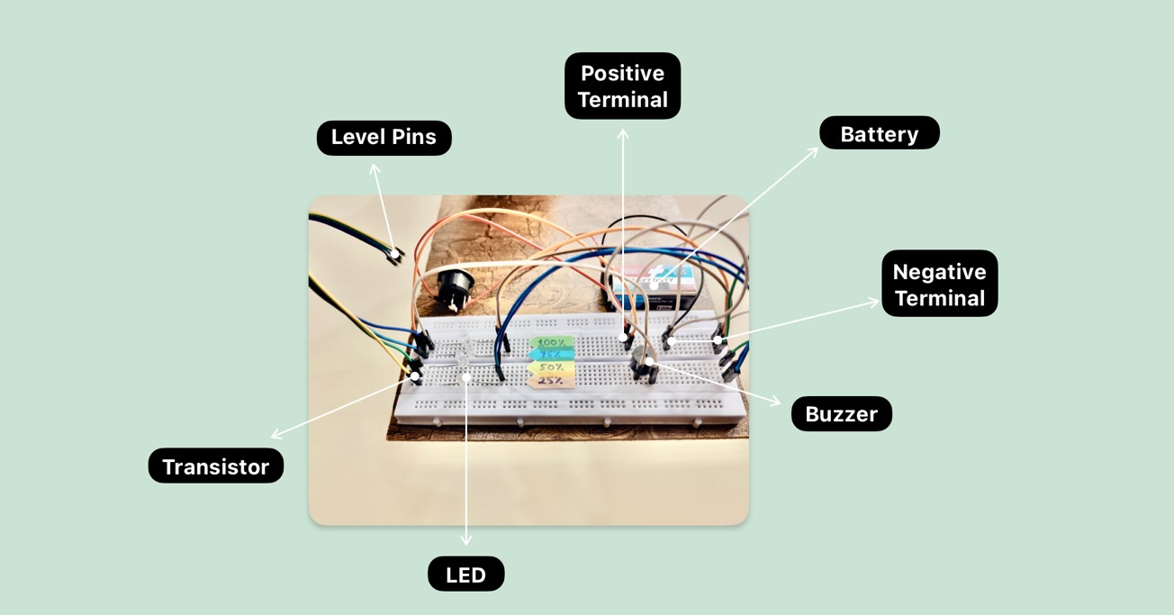

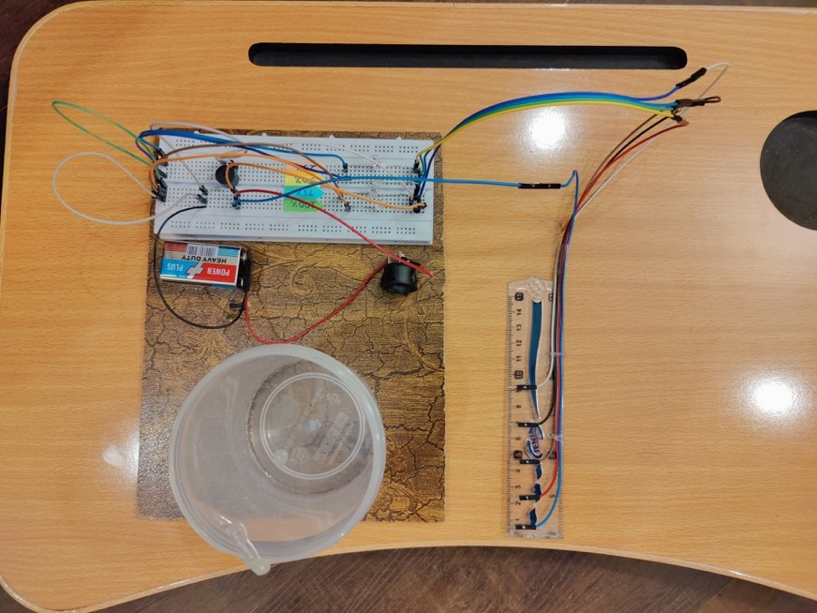

The probe/ruler on which we put pin for different level;

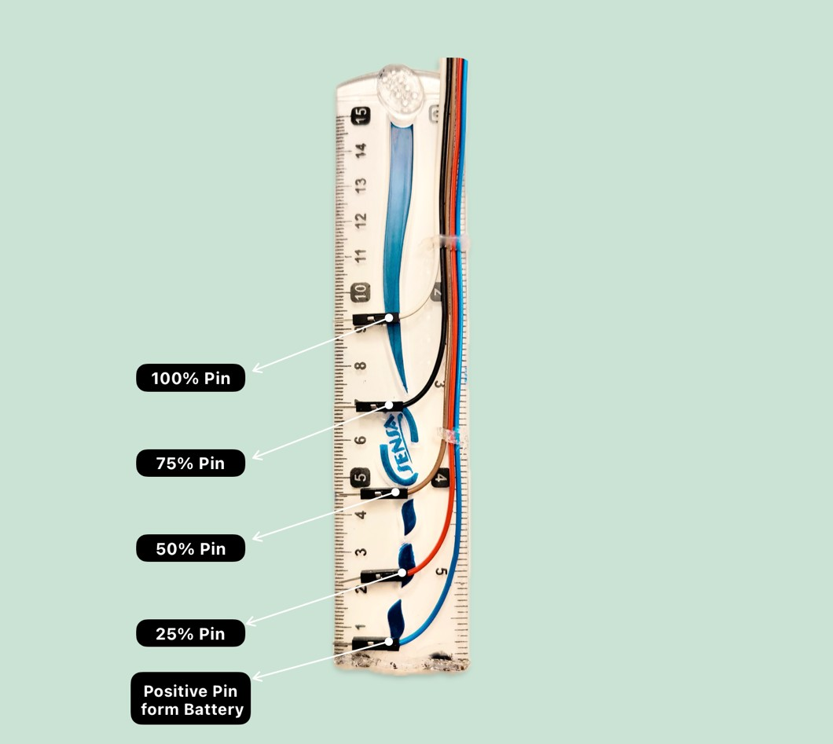

## Software Implication:

The software for this project was designed in proteus and after designing the circuit digitally then we proceed to build it with hardware.

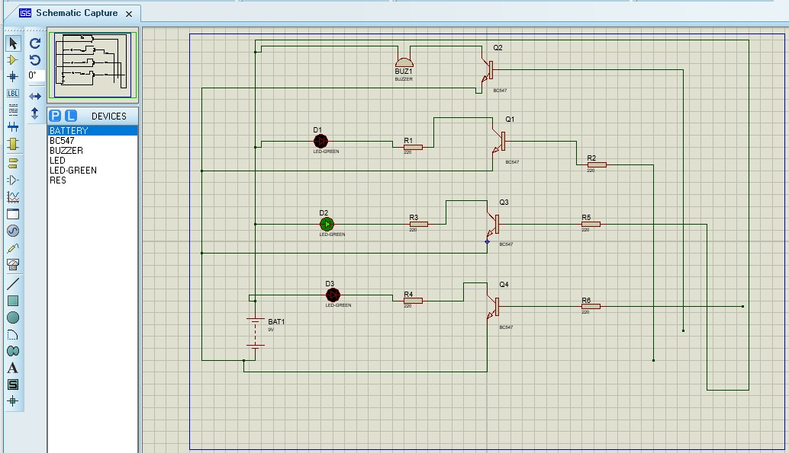

## Limitations:

Following are the some of the limitations of our project;

1. It can only measure the water at certain level where wire is placed.
2. It can’t measure water level if it is between any two levels.

## Conclusion:

In conclusion, the water level indicator project presented here serves as a straightforward and practical solution for users seeking a homemade method to monitor water levels. This simple model, comprised of common components such as a breadboard, transistor, LEDs, connecting wires, and a buzzer, efficiently addresses the need to indicate water levels in reservoirs or overhead tanks. Its user-friendly design and cost-effectiveness make it accessible for a wide range of applications, offering a valuable tool for water management. By providing a clear visual and audible indication of changing water levels, this project demonstrates how basic electronic components can be harnessed to create a useful and reliable system for everyday use.